Sunday Kids Club
Huntly Nordic and Outdoor Centre

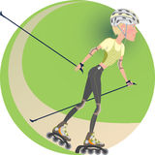

SESSIONS

Sunday 18th June
Sunday 20th August
Sunday 17thSeptember
Sunday 8nd October
Sunday 19th November
Sunday 10 ^{th} December

Please arrive at 1245 for Kit Issue.

CLOTHING LIST
Waterproof Jacket (in wet weather).
Layers of thin stretchy clothing (preferably not cotton).
Bring your own Cycle Helmet if you have one.
Gloves

Huntly Nordic and outdoor centre
Hill of haugh
Huntly
Ab54 4sh
01466 794428

Email: hnoc@aberdeenshire.gov.uk
www.nordicski.co.uk/hnoc

Sunday Kids Club
Huntly Nordic and Outdoor Centre

Registration

Name_____________________________ Age_______
Shoe Size __________ Class __________
Name_____________________________ Age_______
Shoe Size __________ Class ___________
Name_____________________________ Age_______
Shoe Size __________ Class ___________
Parent/Guardian Name ___________________________

Address _______________________________________

______________________________________________

_________________________Post Code _____________

Tel _____________________ Tel _ _________________

E-mail _____________________ ___________________

Prices

£8.50 per session.

All Roller skiing and Skiing equipment provided.

Cheques payable to Aberdeenshire Council
Please phone/email in advance to book place.

PARENTAL CONSENT FORM

- I have read the information issued concerning this activity. I understand the nature of the activity to be undertaken and I consider my child fit to take part.

- I hereby consent to the submission of the below named to emergency medical or surgical treatment including the administration where necessary of a local, general or other anaesthetic.

- I also agree to take responsibility in respect of any, loss, damage or injury occurring, which is directly attributable to his/her misbehaviour or disobedience.

- I do/do not Consent to my child being photographed. ( delete as appropriate)

EMERGENCY
CONTACT NAME:
TEL NOS:
DOCTOR’S NAME:
TEL NO:
ADDRESS:

Please circle the following as appropriate, indicating any conditions that affect your child.

ASTHMA ALLERGY (specify) RECENT SURGERY OTHER

Give further information as appropriate:

NAME (Parent / Guardian): (Block capitals)

SIGNED: DATE:

Sunday Kids Club
Huntly Nordic and Outdoor Centre

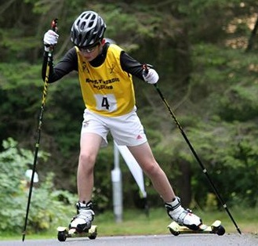
Ages 6-14
Sunday Afternoons 13.00-15.30
From 18th June 2017

Learn to XC Ski and Roller ski

